PRESS MATERIAL:

THE WAIT
- A documentary film by Emil Langballe

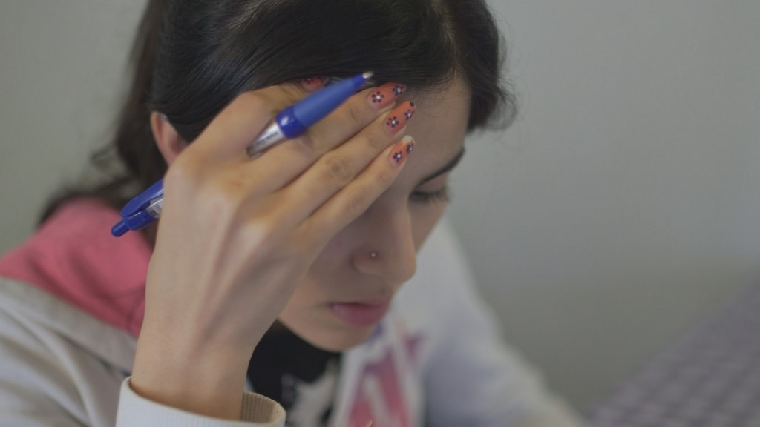

World Premiere: IDFA 2016 PANORAMA SECTION
Duration: 58 min

International distribution: DRSales, www.drsales.dk by Kim Christiansen, kimc@dr.dk
Mobile number: +4542949398

Publicist: Line Bilenberg, line.bilenberg@gmail.com - +45 20710494.
To download press material: www.madeincopenhagen.dk

Produced with the support from The Danish film Institute & TV2 Denmark.
CONTENT

Page 2: Introduction
Page 2: Synopsis
Page 3: Timeline
Page 6: Director’s Statement by Emil Langballe
Page 7: Biographies
Page 8: About made in copenhagen

INTRODUCTION
"They have destroyed me, but I won’t let them destroy others," says the 16-year-old Rokhsar Sediqi about her decision to let a film crew follow her over the past two years, while she and her family have been waiting for a decision in their ”asylum case” in Denmark.
The Sediqi family’s case has been dragged out for almost six years, and there still is no decision.
The long wait has transformed the otherwise well-integrated and resourceful soccer girl, Rokhsar, from Give into a psychologically fragile girl, who has been admitted to a psychiatric ward for children because of panic attacks and suicidal thoughts, and who now has a respite foster family.
International studies show that traumas caused by living in uncertainty for many years can be very harmful and extremely difficult to heal. (See sources at the end of this document).
For several years Rokhsar has shouldered the heavy burden of being the only one in the family who is able to read the letters the family receives from the authorities; letters that are always in Danish despite the fact that her parents do not speak the language. That is why Rokhsar has spent almost six years taking on the responsibility of making sure her family is understood correctly in their communication with lawyers, case workers and the Danish Immigration Service. She is acutely aware that this is a responsibility that will determine the future of her entire family.
Rokhsar’s parents would like to work. But the law prevents them from doing so, and it is psychologically hard on them. In fact the wait is hard on everyone in the family.
Rokhsar’s family fled Afghanistan when she was 10 years old. Her oldest brother was killed by the Taliban. The family had lived in hiding from the Taliban for years, partly because they were looking to recruit the sons of the family.

SYNOPSIS

A film about an Afghan girl and her family, who after six years are still waiting for an answer on their asylum application.

The film begins when Rokhsar Sediqi is 14 years old and in the 7th grade. She lives with her mom, dad and five siblings in Give, close to Vejle in the countryside of Denmark. In her spare time she plays for the local girls’ soccer team.
It has been four years since Rokhsar and her family fled Afghanistan. After six months of illegal border crossing through Europe, they ended up in Denmark, where they applied for asylum. But the Danish Immigration Service questions whether they are in fact being persecuted by the Taliban in Afghanistan and has denied the family asylum several times.

Most of the other family members have been traumatised by the circumstances surrounding their escape from Afghanistan, and since Rokhsar is the only one who speaks Danish fluently, it is primarily she, who has to advocate for her family. Despite her young age, she is the one in charge of communication with the Red Cross, the Danish Immigration Service, lawyers, interest groups etc. And when they receive letters from the authorities with updates on the status of their application, she is the one who opens them, the one who translates and explains it to her parents. Often she keeps bits of the information to herself in order to protect them, but the weight of the responsibility she shoulders begins to wear on her. It is hard for her to find time and energy to see her friends and to attend to her school and hobbies. In other words, she is forced to grow up too quickly.

Years ago they were denied asylum, and for a while they lived in constant fear, expecting the police at their door any day, facing the risk of being escorted to the airport and put on the first plane back to Afghanistan, where they would have to start from scratch. They fear the Taliban will kill them. Besides, Rokhsar was only ten years old when she left the country and has nothing to return to. She feels Danish.

However, the family has one last option left. They have applied for residency permit through the special paragraph 9 C – 1 in the Danish Immigration Law, which is about special circumstances concerning children. The argument is that Rokhsar has spent many of her formative years in Denmark and that it will be against her best interest to send her back to Afghanistan, since she has already integrated into the Danish society by going to school, speaking Danish fluently, playing soccer and so on. If the immigration authorities approve, Rokhsar AND her family will be permitted to stay in Denmark indefinitely. If not, they will be deported. The family is currently waiting for the decision and can stay in Denmark legally until it comes.

Using the language of observational filmmaking, we have been following the family closely over a period of two years in order to document human consequences of the Danish immigration policy. We want to show what it is like to be at the receiving end of the systematic criminalisation and rejection of immigrants and how it affects a child to be living in a limbo for years, when every single day is uncertain and contains the possibility of a tragic outcome.

ROKHSAR’S FAMILY & CASE TIMELINE

The family consists of:

Sediqa Sediqi, mother, b. May 12, 1966
Gulam Mustafa Hahsimi, father, b. 1961

Medina Sediqi, younger sister, April 25, 2002
Rokhsar Sediqi, b. May 12, 2000
Mokhtar Sediqi, big brother, b. July 7, 1998
Moska Sediqi, big sister, b. June 4, 1997
Mojtaba Sediqi, big brother, b. May 12, 1995
Morteza Sediqi, big brother, b. May 12, 1993

22.11.2010 – Rokhsar’s brother Abdulla dies
Rokhsar’s brother, Abdullah, is murdered, and the next day the family flees the country. The family consists of the parents and their six children of which Rokhsar is the second youngest. They flee in two cars. In one car sits Rokhsar, her mother and the two oldest brothers, Morteza and Mojtaba.

In the other sits Rokhsar’s father, the big sisters, Moska og Medina, and the youngest of her big brothers, Mokhtar.
When they reach the Afghan border, the father’s car is detained, and for the next couple of years, Rokhsar, her mother and two brothers live with the possibility that the other half of their family has probably been killed.

7.12.2010 Rokhsar, her mother and brothers arrive in Greece
Rokhsar, her mother and the two brothers end up in Greece, where they stay for six months. Here they get in contact with a human trafficker and are put on a truck that drives up through Europe. After three days without food and water, they suddenly find themselves in Denmark.

09.05.2011 Rokhsar, her mother, Morteza and Mojtaba arrive in Denmark
The four family members are taken to the refugee camp, Sandholmlejren, and from there they are transferred to an asylum centre in Auderød, where they live for two years.

18.05.2011 – The family seeks asylum in DK

27.05.2011 - Rokhsar, Sediqa, Morteza and Mojtaba arrive at Auderød
The family has stayed for 15 days in Sandholmlejren before they arrive in Auderød, where they will be living for the next two years.
Rokhsar is quick to learn Danish, and after only six months in the asylum centre’s school, she is enrolled in a regular public school, where she makes Danish friends, starts to play football and learns the language in no time.
The two big brothers, Morteza and Mojtaba are both too old for public school, but, like the mother, they are eligible to receive the minimal Danish language instruction at the asylum centre together with other asylum seekers. A little later in the process, they enrol in a language course.

18.10.2011 - The Danish Immigration Service denies Sediqa's request for asylum, and she now seeks residency through the Refugee Appeals Board
The family still has access to Danish language instruction at the asylum centre, albeit very limited in scope. Meanwhile Rokhsar continues to go to school under Article 28 of the Convention of Rights of the Child (CRC), which states that a child has a right to an education.
This means that, for all intents and purposes, Rokhsar is the only one in the family who learns to speak Danish well enough to cope amongst Danes. This also means she is the only one who can speak with the authorities and read the important letters the family receives in Danish, such as the denial of asylum.
The now 12-year-old girl feels the pressure mounting with each application and appeal. She feels that it is her responsibility to argue the family’s case to lawyers, case workers and the Danish Immigration Service.

27.06.2012 – Sediqa’s appeal with the Refugee Appeals Board is denied
Rokhsar’s mother’s appeal with the Refugee Appeals Board is denied, but she applies for asylum for humanitarian reasons with the Ministry of Justice. Her argument is that she cannot be sent back to Afghanistan because she is a single woman.
27.07.2012 – Sediqa applies with the Ministry of Justice for a residence permit on humanitarian grounds
The application is based on the fact that she is a single woman and therefore cannot be sent back to Afghanistan with three children.

6.11.2012 – Rokhsar’s father, Gulam, and the three remaining siblings are registered by the police in Greece
Rokhsar, her mother and two brothers do not know about this, and they still fear that the father and the three siblings died during the escape.

19.11. 2012 Rokhsar is admitted to Hillerød Hospital and then the psychiatric ward for children at Glostrup Hospital, because she has suicidal thoughts

25.03.2013 – Rokhsar’s father, Gulam, her big brother, Mokhtar, big sister, Moska, and younger sister, Medina, show up in Denmark
Rokhsar, her mother and the two brothers are still waiting for a decision from the Ministry of Justice in March 2013, when they get a call from Red Cross who believe to have found the rest of the family.

30.10.2013 – Sediqa’s application for a residence permit on humanitarian grounds is denied.
Despite a medical specialist determining that she suffers from PTSD, Sediqa is denied a stay on humanitarian grounds. One of the reasons for the denial is that she is no longer a single mother now that she has been reunited with her husband.

Immediately after the denial of Sediqa’s application, Rokhsar’s father, Gulam, applies on his own behalf, and the whole process starts all over again.
The adults are offered Danish Language instruction at VUC the moment the application is registered and is being treated, and the offer is pulled back just as quickly when the application is denied.
Rokhsar’s younger sister, Medina, and the youngest of her big brothers, Mokhtar, start at the asylum centre’s school.
A month after their reunion, the family receives housing in Give.

Meanwhile, Rokhsar’s Danish has improved tremendously. She is the second youngest in her family, but she is miles ahead in speaking the language, and she is able to navigate all kinds of situations. This makes her the one on which everyone depends for homework, translation, meetings with lawyers and case workers.

09.12.2013 – Gulam’s asylum application is denied by the Danish Immigration Service, and he appeals the case with the Refugee Board of Appeals

14.04. 2014 - Gulam appeal is denied by the Refugee Appeals Board
The family receives this news in a letter – in Danish. Rokhsar reads the letter and keeps it hidden from her family, who are unable to read and understand it, for two days. The Refugee Appeals Board was the family’s last chance, and it has been determined that the family has to leave Denmark within 15 days.

But the family has nowhere to go, and the then 14-year-old Rokhsar tries to find out on her own what they can possibly do. She receives the discouraging and shocking news that they can be picked up by the police and put on a plane back to Afghanistan at any given moment.
Rokhsar tells that she lies awake every night, listening for the police. She gets almost no sleep. And then one day, one of the other Afghani families they know, are picked up and sent back to Afghanistan.

Autumn 2014 – With assistance from the Refugee Appeals Board and a private lawyer, Aage Kramp*, the family applies once again for residence through the Danish Immigration Service on the grounds that Rokhsar has become integrated and has ties in Denmark

9.12.2014 - Rokhsar collapses
Shortly after, Rokhsar falls apart and faints. She is brought to Vejle Hospital and is admitted overnight for observation.

13.1.2015 - The family is placed in Phase 2 when the Danish Immigration Service reconsiders their application based on section 9(c), concerning the best interest of the child
The Danish Immigration Service reconsiders the family’s case, this time on the grounds of Rokhsar’s integration and the best interest of the child as laid out in the section 9(c).
Once again the adult members of the family gain access Danish Language instruction.

The family had been promised they would receive a decision in October 2015. It still has not arrived. At the same time, Rokhsar is so ill that she is offered a respite foster family whom she visits every other weekend, so she can have some peace and quiet.

16.9.2015 - Rokhsar is again admitted to the psychiatric ward for children in Odense because of intrusive suicidal thoughts

DIRECTOR’S STATEMENT
Over the two years I have followed Rokhsar and her family, I have witnessed how the system has broken down and destroyed an otherwise happy and resourceful teenager.

Rokhsar is the only one in her family that is fluent in Danish, and since all communication from the authorities is in Danish without any offer of translation services, Rokhsar has had to act as translator, lawyer and a kind of buffer between the authorities and her own parents.

She has had to carry the burden of the family’s fate on her shoulders, and that has destroyed her. She has had to sacrifice both her youth and her teenage life, but the system has also turned the family structure upside down. The system has forced her to grow up overnight, and she has become a parent to her own parents. Her father, who was the family’s incontestable patriarch in Afghanistan, has been rendered utterly powerless and has no choice but to leave the destiny of his family in the hands of his 14-year-old daughter.

The Wait is a kind of injurious coming-of-age story about a girl, who lives her teenage life in an inhumane limbo, where every day may turn out to be her last in Denmark; a girl who is forced by the Danish system to grow up too soon.
But it is also the story about how our authorities fail hundreds of children of asylum seekers all around the country. Children who, like Rokhsar, are forced by the system to act as translators for their parents while they wait for years for an answer from an inhumane and phlegmatic system, and where they live in daily fear of being deported, something that could happen on any given day.

BIOGRAPHIES:
Director, Emil Langballe
Emil Langballe (b. 1982) studied broadcast journalism and video production in Aarhus and New York before he went on to do an MA in documentary filmmaking at the British National Film and Television School. His graduation film ‘Beach Boy’ (2013) travelled all over the world and was awarded in festivals like Karlovy Vary, Thessaloniki, Tampere and Hot Docs.
Since then Emil has directed the children’s doc series, Josefine’s Farm (CPH:DOX 2015).
The Wait is his first longer documentary film.

Co-director, Andrea Storm Henriksen
Andrea holds an MSc in Strategic Communication from Copenhagen Business School and an MA in TV and Media Production from the Danish School of Media and Journalism. Andrea has worked as a copywriter and concept developer for digital agencies before focusing on journalism and documentary filmmaking. During the past five years, Andrea has been involved in different documentary films and TV productions and has worked as a video journalist for SOS Children villages in Africa and Asia. Currently she is working on a documentary series about torture for DR TV.

Producer, Helle Faber
Helle graduated from the Danish School of Media and Journalism in 1991 and has worked as a producer of documentary films since 2003. She has produced a great number of award-winning documentary films for both the national and international markets. Productions such as Motley’s Law (2016), Warriors from the North (2014), Putin’s Kiss (2011) and The Dark side of Chocolate (2010).
Faber is CEO and sole proprietor of made in copenhagen, a production company which she founded in 2010.
At this year’s IDFA the company presents two new films: The Wait (Panorama Section) and Who We Were (First Appearance Competition).

Cinematography:
Emil Langballe

Additional cinematography:
Andrea Storm Henriksen

Editor:
Michael Aaglund & Peter Winther

Sound design:
Rasmus Winther

Composer:
Uno Helmersson

ABOUT MADE IN COPENHAGEN
made in copenhagen produces complex stories from the real world for international audiences. The company’s primary focus is to portray a reality that isn’t black and white but rather full of nuances. In other words, the films seek to take the audience behind the mainstream news media, to touch them through memorable characters and to incite to debate.
Over the past five years, made in copenhagen has become one of the most influential documentary film companies in Denmark with award-winning titles such as Motley’s Law, Warriors from the North, Putin’s Kiss and Shady Chocolate. made in copenhagen has a strong team of experienced directors and new talents. The company has established itself firmly in a growing international network. It was founded in 2010 by producer Helle Faber who is also managing director of the company.

www.madeincopenhagen.dk

Sources: Hallas P, Hansen AR, Staehr MA, Munk-Andersen E, Jorgensen HL. Length of stay in asylum centres and mental health in asylum seekers: a retrospective study from Denmark. BMC Public Health 2007;7(147):288.
Laban CJ, Gernaat HB, Komproe IH, Schreuders BA, De Jong JT. Impact of a long asylum procedure on the prevalence of psychiatric disorders in Iraqi asylum seekers in The Netherlands. J Nerv Ment Dis 2004 Dec;192(12):843-51.
Silove D, Sinnerbrink I, Field A, Manicavasagar V, Steel Z. Anxiety, depression and PTSD in asylum-seekers: assocations with pre-migration trauma and post-migration stressors. Br J Psychiatry 1997 Apr;170:351-7.

